Formative Assessment Name: ANSWER KEY
BIOLOGY: The Digestive System (Difficult) Time: 15 minutes

Question 1: Decreased secretions from the gallbladder would cause a/an: (1 mark)
- Decreased absorption of simple fats in the small intestine.
- Increase in peristalsis of the digestive tract.
- Decreased production of proteins.
- Reduction in digestive enzyme release from the pancreas.
Question 2: Which of the following chemical changes would take place in the stomach? (1 mark)
- Breakdown of proteins by protease enzyme
- Breakdown of proteins by hydrochloric acid
- Breakdown of carbohydrates by amylase enzymes
- All of the above
Question 3: What structure(s) of the small intestine help speed up the rate of absorption of nutrients into the blood? (1 mark)
- Cillia
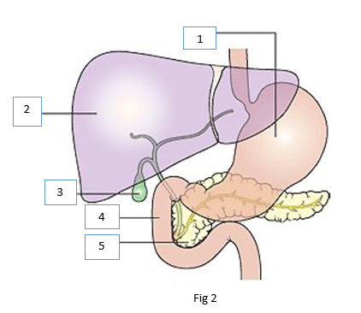
- Villi & microvilli
- Flagella
- Enzymes

Question 4: Refer to the diagram Fig 2, which shows part of the human digestive system.
Identify the structure that stores substances involved in mechanical fat digestion. (1 mark)

- 2
- 3
- 4
- 5

Question 5: Carbohydrates, proteins and fats are all digested in different parts of the body. Which row in the following table shows where each of these three groups are first broken down? (1 mark)
 | carbohydrate | protein | fats
(a) | mouth | small intestine | stomach
(b) | mouth | stomach | small intestine
(c) | small intestine | stomach | small intestine
(d) | stomach | mouth | small intestine

Question 6: Peristalsis moves food material. (1 mark)

- in the stomach and small intestines only.
- in the stomach and intestines only
- from the pharynx to the anal canal
- in the oesophagus and stomach only.

Question 7: State two main functions of the large intestine. (2 marks)
- Absorption of water
- Absorption of electrolytes (sodium, potassium) or Formation & storage of faeces

Question 8: Digestion of food can occur both mechanically and chemically.
- Describe two examples of mechanical digestion by completing the table below. (4 marks)
Mechanical Digestion Process | Description
ANY TWO:  - Chewing / mastication  - Peristalsis  - Churning  - Emulsification | ANY MATCHING TWO:  - Teeth, tongue & mouth break food into smaller pieces by grinding (food becomes a bolus)  - Movement of food through digestive tract breaks it into segments.  - Stomach breaks down food into smaller pieces by mixing (bolus becomes chyme)  - Bile breaks down large fat droplets into smaller fat droplets.

- Complete the table below summarising the enzymes involved in the chemical breakdown of nutrients. (3 marks)
Chemical Digestion Process | Specific Enzyme
Chemical break down of carbohydrates | Amylase
Chemical break down of proteins | Protease
Chemical break down of fats | Lipase

