Name: _________________________________
Exploring Microscopes
"Micro" refers to tiny, "scope" refers to view or look at. Microscopes are tools used to enlarge images of small objects so as they can be studied. The compound light microscope is an instrument containing two lenses, which magnifies, and a variety of knobs to resolve (focus) the picture. Because it uses more than one lens, it is sometimes called the compound microscope in addition to being referred to as being a light microscope.

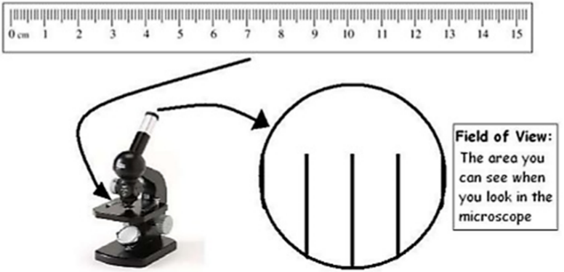
TASK 1 – Measuring FOV
- Set the microscope to a low power magnification by rotating the nosepiece to the shortest objective lens.
- Place a clear plastic ruler on the stage.
- Focus the ruler until you see the field of view.
- Measure the diameter of the field of view in millimeters.

1. Record the diameter of the low power field of view in the table below.

Magnification | F.O.V. (mm) | F.O.V. (µm)
Low Power

2. Determine how magnification impacts the image viewed under the microscope by comparing the following in low power vs high power.
 | Size of F.O.V. |  | Light |  | Amount seen |  | Amount of detail
Low Power |  | Larger |  | Less light |  | See more |  | More detail
 |  | Smaller |  | More light |  | See less |  | Less detail
High Power |  | Larger |  | Less light |  | See more |  | More detail
 |  | Smaller |  | More light |  | See less |  | Less detail

TASK 2 – Images under microscopes
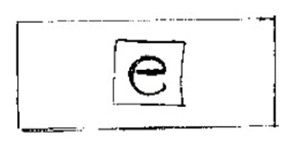

1. Draw & describe what do you see when you put an ‘e’ slide under a microscope?

2. When looking at the letter “e”:

Look down the microscope and more your slide… | What do you observe?
a) Away from you
b) Towards you
c) To the left
d) To the right

TASK 3 – Viewing Pre-Made Slides
Observe a variety of fibers & insects under the microscope. Record your observations below.
Sample / Specimen | Magnification | Observations

