Formative Assessment Name: ___________________________
BIOLOGY: The Digestive System Time: 15 minutes

Question 1 (1 mark)
The gastrointestinal tract includes all the following, except;

A. oesophagus
B. stomach
C. small intestine
D. liver

Question 2 (1 mark)
Gastric juices in the stomach:

A. kill bacteria
B. work together to digest food
C. include hydrochloric acid
D. all of the above

Question 3 (1 mark)
The stomach:

A. only does chemical digestion
B. only does mechanical digestion
C. does both chemical and mechanical digestion
D. starts the chemical digestion of starchy foods.

Question 4
Villi are found in the digestive system. The diagram below shows 2 villi.

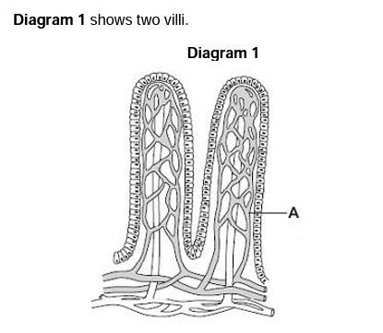
a) Name the structure labelled as A: Capillary (1 mark)

b) Draw a circle around the correct answer to complete the sentence. (1 mark)

The villi absorb the products of digestion by: dialysis diffusion osmosis

c) Refer to the diagram of the digestive system below to answer the questions.

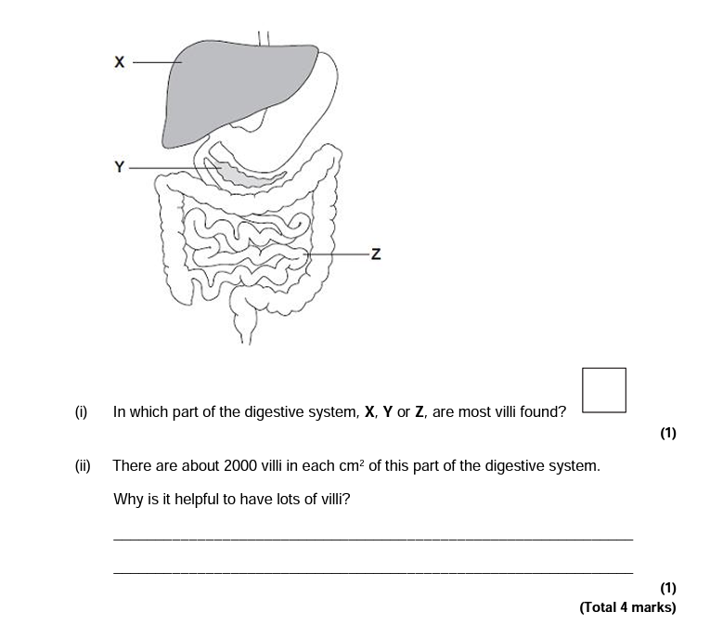
i) In which part of the digestive system, X, Y or Z are most villi found?
____Z____ (1 mark)

ii) There are about 2000 villi in each cm² of this part of the digestive system. Why is it important to have lots of villi? (2 marks)

1 mark – increase surface area (larger surface area to volume ratio)

1 mark – Absorption occurs at a faster rate.

iii) Name the parts labelled in the diagram above and describe their role in the digestion of food. (6 marks)

Diagram label | Name | Function
X | Liver | Makes bile which helps to break down fat molecules.
Y | pancreas | Released bicarbonate to neutralise stomach acid as it enters intestines  Produces enzymes that digest carbohydrates, proteins and fats
Z | Small Intestine | Digests food and absorbs nutrients into blood stream

PERSONAL LEARNING REFLECTION
One thing I have learnt from doing this activity is… | SCORE:  ______ / 14  _______ %

